**OTMC Subscription Management System**

Presented by:

Josiah Rodriguez

**Table of Contents**

**1.** **Analysis Strateg****ies and Techniques 4**

**2****. Requirements Analysis** **5**

2.1 Use Cases Descriptions 5

2.2 Use case Diagram 9

**3****. Use case realizations** **10**

3.1 Behavioral models (interaction diagrams) 10

3.2Structural models (class diagrams) 13

3.3 Domain Model 15

**4****. System architecture** **16**

**5****. User interface design** **17**

**6****. Data storage design** **20**

6.1 Entity Relational Diagram: 20

6.2 Database Files Organization: 20

**Appendix 1: Interview reports and questionnaires** **23**

**List of Tables**

6.2 Database Files Organization

* Table I: Customer
* Table II: Subscription
* Table III: Membership
* Table IV: Product
* Table V: Payment

**List of Figures**

2.2 Use case diagram

3.1 Behavioral models (interaction diagrams)

* Interaction Diagram 1
* Interaction Diagram 2
* Interaction Diagram 3

3.2 Structural models (class diagrams)

* VOPC – Use Case 1
* VOPC – Use Case 2
* VOPC – Use Case 3

3.3 Domain Model

4. System Architecture

5. User interface design

Windows Navigation Diagram

* Wireframe 1
* Wireframe 2
* Wireframe 3

6.1 Entity Relational Diagram

# Analysis Strategies and Techniques

# 1. Project Summary

The Of-the-Month Club (OTMC) Subscription Management System is a pivotal project designed to transform the current paper-based operation into a dynamic, digital platform. This system is being developed by a team of software engineers, project managers, and system analysts employing Agile methodologies, particularly Scrum, to ensure adaptability and responsiveness to customer needs. As soon as the system is fully developed and rigorously tested—which is projected to be within a year from its initiation—it will be employed by OTMC to manage various membership subscriptions, process payments securely, and handle the logistics of monthly product deliveries.

The system is tailored primarily for OTMC's staff and its customers, enhancing the efficiency of internal operations and improving customer interaction with the service. Utilized daily at OTMC’s operational offices and accessible online for customers, the system aims to facilitate seamless management of customer subscriptions and improve the overall customer experience. It integrates a user-friendly interface with robust backend functionalities that manage data processing and storage, ensuring that all operations from customer registration to payment processing are streamlined and secure.

The development of the system is driven by the necessity to support OTMC's strategic goals of expanding its membership offerings and improving operational efficiencies. It is built to accommodate a growing product range and varying membership durations, from monthly to semi-annual options. By replacing the outdated paper system, OTMC anticipates not only enhanced operational efficiency but also an increase in customer satisfaction and market competitiveness. The system will be predominantly used at OTMC headquarters but is designed to be accessible to customers from different locations, providing a flexible and comprehensive platform to manage their subscriptions.

In essence, the OTMC Subscription Management System represents a significant leap towards modernizing the company's operations, ensuring scalability, and enhancing customer engagement through technological innovation. This strategic initiative is expected to play a crucial role in driving the growth and profitability of OTMC by catering to a broader customer base and adapting to market dynamics efficiently.

# 2. Requirements Analysis

### 2.1 Use case descriptions

### Use Case 1: Register New Member

**Characteristic Information:**

**Brief Description:** This use case allows a telephone operator to register a new member in the system.

**Primary Actor:** Telephone Operator

**Stakeholders:** Telephone Operator, New Member

**Trigger:** Telephone operator starts the registration process in the system.

**Preconditions:** Telephone operator is logged on to the system.

**Guarantees**:

Success End Condition: New member is successfully registered and receives a confirmation.

Failed End Condition: Member registration fails and no data is saved.

**Main Success Scenario:**

The system prompts the telephone operator to enter member information (name, address, phone number, email, credit card information, start date, and selected memberships).

The telephone operator enters all required data.

The system validates the data according to the business rules.

Upon successful validation, the system saves the member data and sends a confirmation to the telephone operator.

The system sends an email confirmation to the new member.

**Extensions:**

3a. Invalid data entry:

The system notifies the telephone operator of the validation error.

The telephone operator re-enters the data.

4a. System failure during save:

The system logs the error and notifies the telephone operator.

The telephone operator attempts to save again.

**Business Rules:**

| **Number** | **Rule Description:** |
| --- | --- |
| OTMC1 | Member information must include a valid name, address, email, and credit card information. |
| OTMC2 | Memberships must be validated against available options (e.g., coffee, cigars, flowers). |

### Use Case 2: Process Monthly Shipment

**Characteristic Information:**

**Brief Description**: This use case involves the system automatically processing and mailing the monthly shipment to members.

**Primary Actor:** System

**Stakeholders**: Members, Shipping Department

**Trigger**: Scheduled monthly shipment date arrives.

**Preconditions**: Member subscriptions are active.

**Guarantees:**

Success End Condition: Products are shipped to members.

Failed End Condition: Products are not shipped, and members are notified of the delay.

**Main Success Scenario:**

The system retrieves all active memberships due for shipment.

The system generates packing slips for each member's monthly product.

The system sends the packing slips to the shipping department.

The shipping department packs and ships the products.

The system updates the member's record with shipment details.

**Extensions:**

1a. No active memberships found:

The system logs the event and takes no further action.

**Business Rules:**

| **Number** | **Rule Description:** |
| --- | --- |
| OTMC3 | All shipments must include a packing slip with correct member details and product information. |
| OTMC4 | Shipments must be processed on the scheduled shipment date unless delayed by external factors. |

### Use Case 3: Update Member Information

**Characteristic Information:**

**Brief Description:** This use case allows the telephone operator to update existing member information.

**Primary Actor**: Telephone Operator

**Stakeholders**: Telephone Operator, Member

**Trigger:** Member requests an update to their information.

**Preconditions**: Telephone operator is logged on, and member's record is accessible.

**Guarantees:**

Success End Condition: Member information is updated in the system.

Failed End Condition: Member information remains unchanged.

**Main Success Scenario:**

The telephone operator retrieves the member's record.

The member provides the updated information.

The telephone operator updates the information in the system.

The system validates the updated information.

Upon successful validation, the system saves the updated information and notifies the telephone operator.

**Extensions:**

4a. Validation fails:

The system notifies the telephone operator of the validation error.

The telephone operator asks the member for correct information and attempts to update again.

**Business Rules:**

| **Number** | **Rule Description:** |
| --- | --- |
| OTMC5 | Email and credit card updates must undergo validation checks for format and legitimacy. |
| OTMC6 | Address changes must be validated against a recognized address database. |

### 2.2 Use case diagram

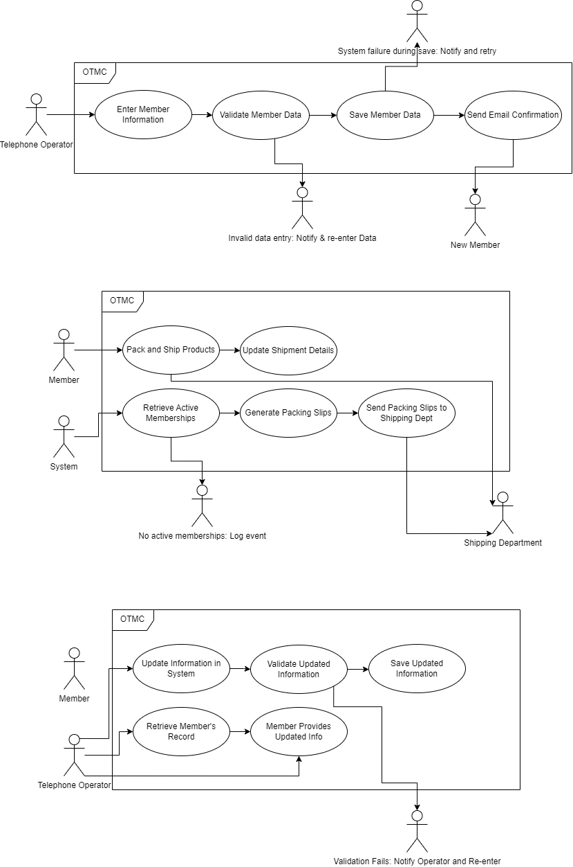

# 3. Use case realizations

### 3.1 Behavioral models (interaction diagrams)

**Interaction Diagram 1**

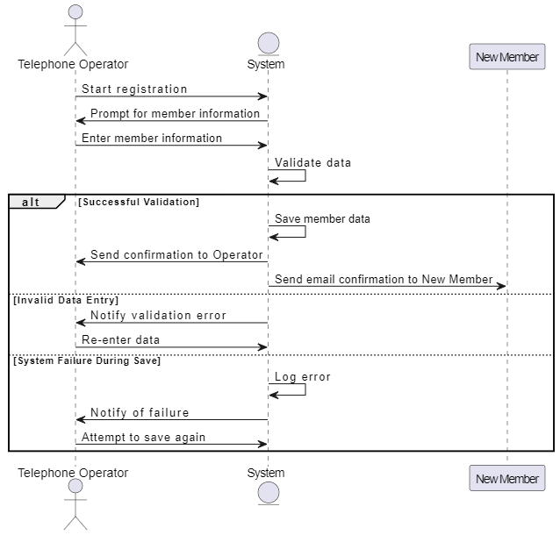

**Interaction Diagram 2**

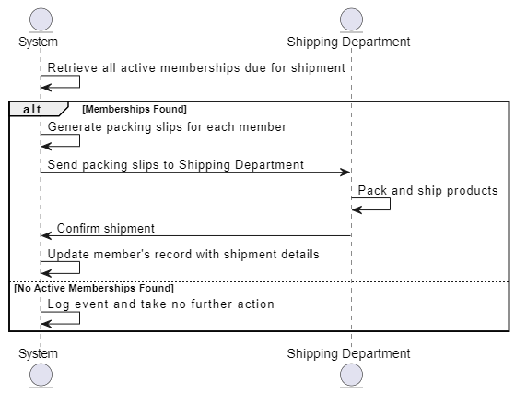

**Interaction Diagram 3**

### 

### 

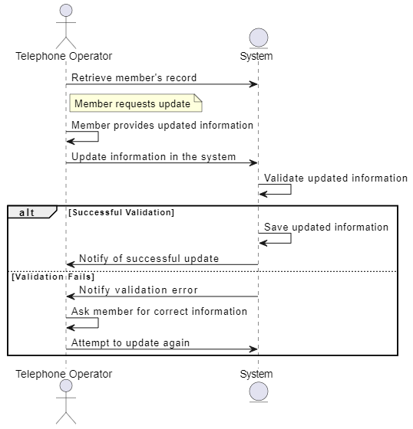

### 

### 3.2 Structural models (class diagrams)

**VOPC – Use Case 1:**

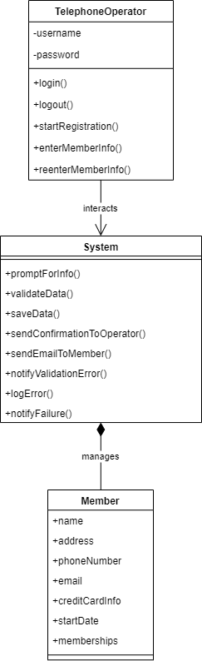

**VOPC – Use Case 2:**

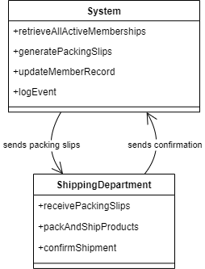

**VOPC – Use Case 3:**

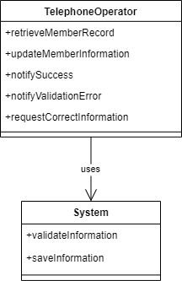

### 3.3 Domain Model

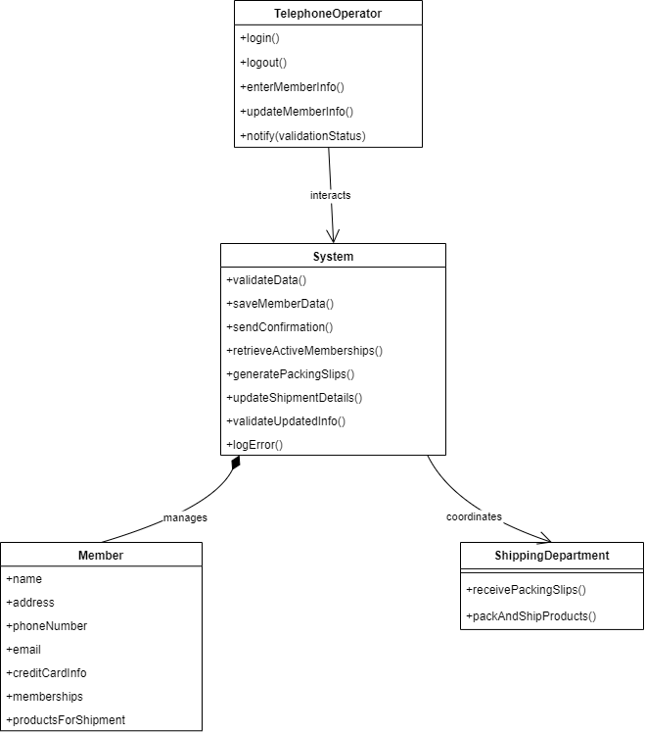

**4. System Architecture**

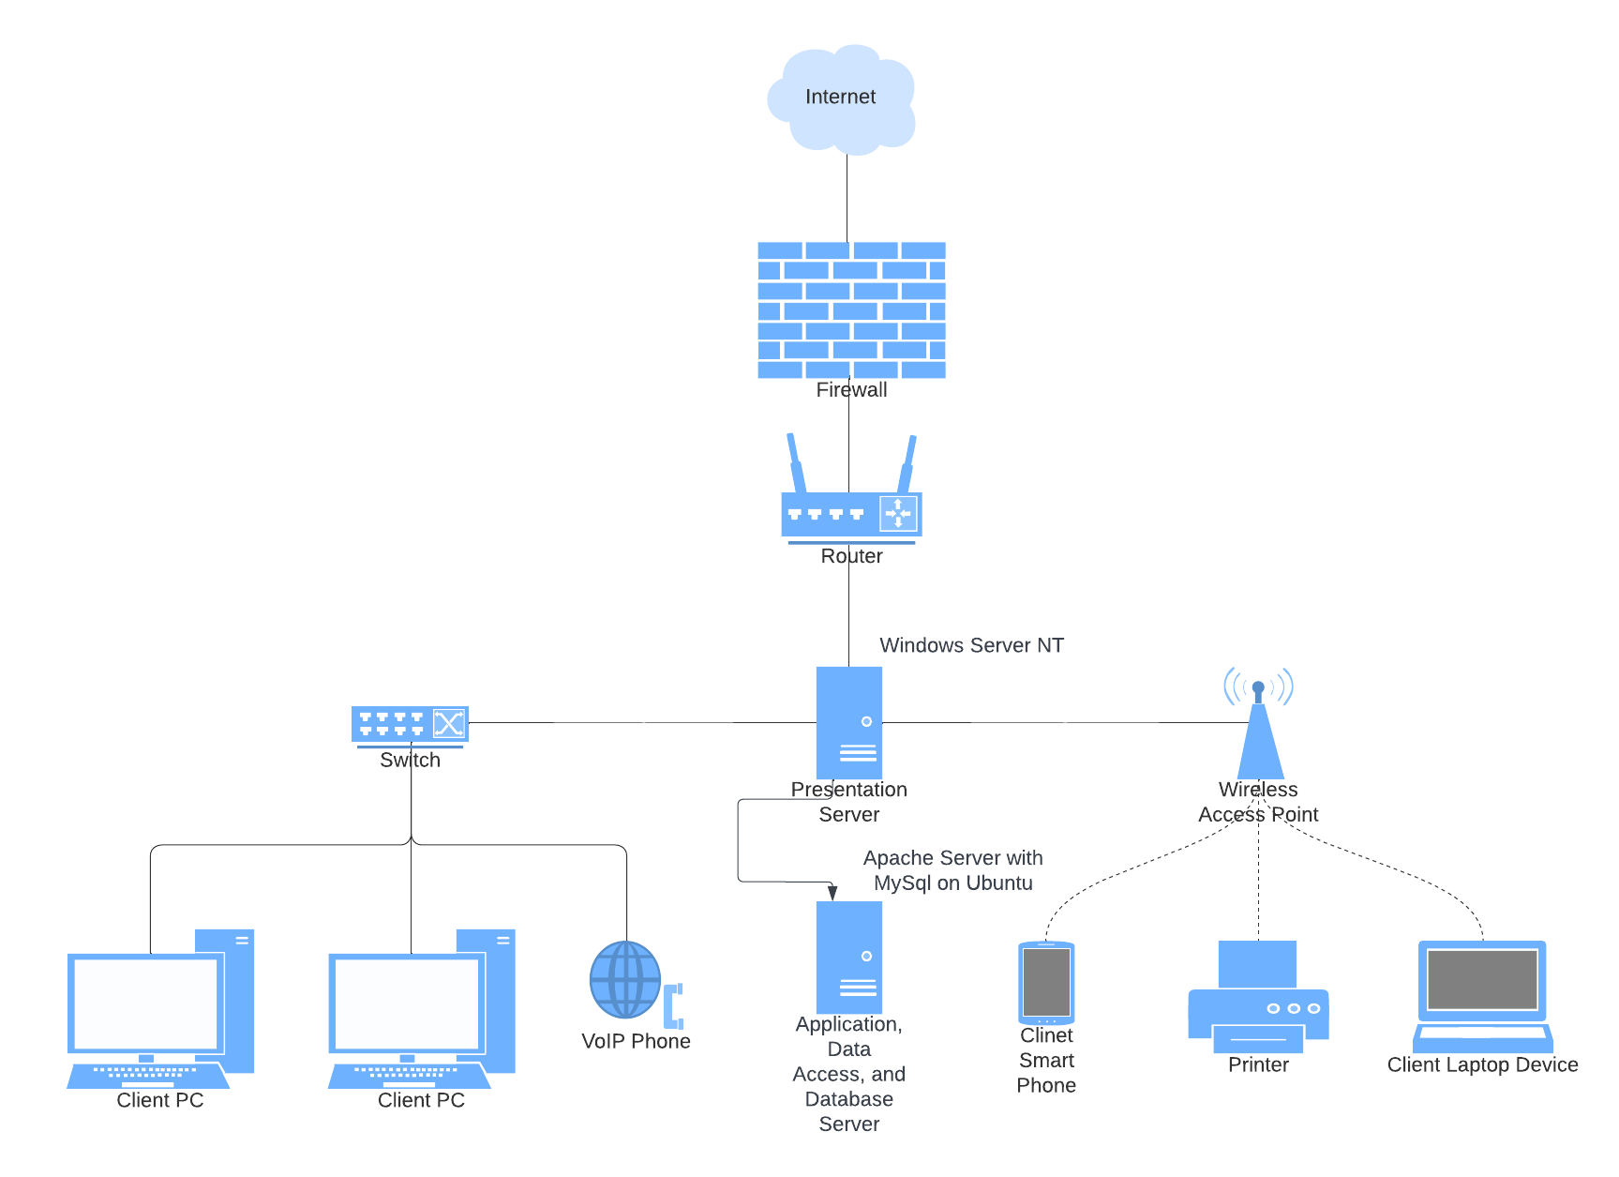

# 5. User interface design

**Windows Navigation Diagram**

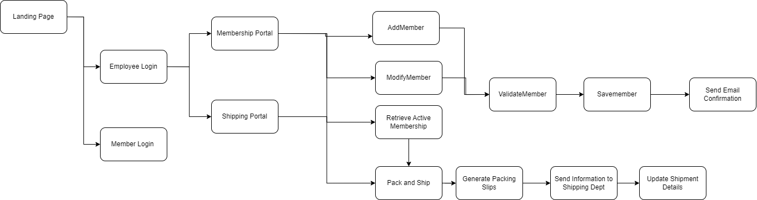

# Wireframe 1:

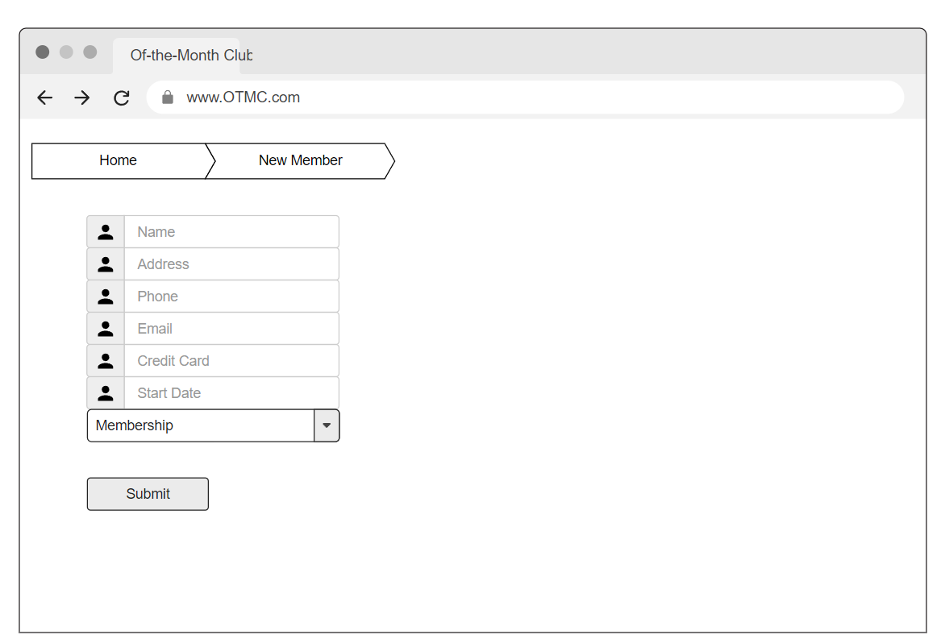

# Wireframe 2:

# Wireframe 3:

# 6. Data storage design

### 6.1 Entity Relational Diagram:

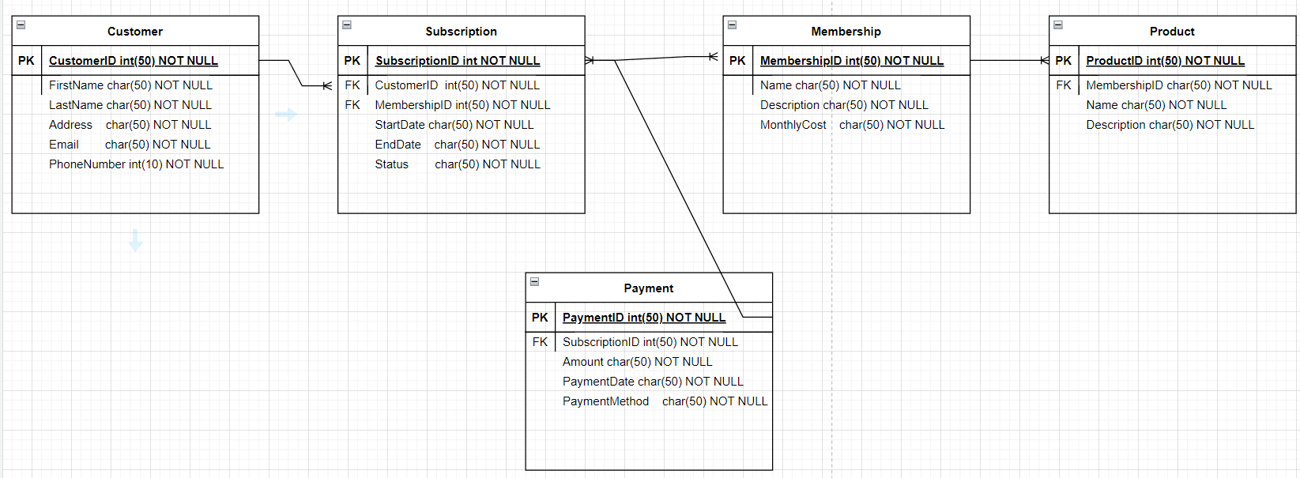**6.2 Database Files Organization**:

**Table 1: Customer**

| **Field Name** | **Size** | **Data Type** | **Key** |
| --- | --- | --- | --- |
| CustomerID | 50 | int | PK |
| FirstName | 50 | char |  |
| LastName | 50 | char |  |
| Address | 50 | char |  |
| Email | 50 | char |  |
| PhoneNumber | 10 | int |  |

**Table II: Subscription**

| **Field Name** | **Size** | **Data Type** | **Key** |
| --- | --- | --- | --- |
| SubscriptionID | 50 | int | PK |
| CustomerID | 50 | int | FK |
| MembershipID | 50 | int | FK |
| StartDate | 50 | char |  |
| EndDate | 50 | char |  |
| Status | 50 | char |  |

**Table III: Membership**

| **Field Name** | **Size** | **Data Type** | **Key** |
| --- | --- | --- | --- |
| MembershipID | 50 | int | PK |
| Name | 50 | char |  |
| Description | 50 | char |  |
| MonthlyCost | 50 | char |  |

**Table IV: Product**

| **Field Name** | **Size** | **Data Type** | **Key** |
| --- | --- | --- | --- |
| ProductID | 50 | int | PK |
| MembershipID | 50 | int | FK |
| Name | 50 | char |  |
| Description | 50 | char |  |

**Table V: Payment**

| **Field Name** | **Size** | **Data Type** | **Key** |
| --- | --- | --- | --- |
| PaymentID | 50 | int | PK |
| SubscriptionID | 50 | int | FK |
| Amount | 50 | int |  |
| PaymentDate | 50 | char |  |
| PaymentMethod | 50 | char |  |

# 

# 

# 

# 

# 

# Appendix 1: Interview reports and questionnaires

**Interview reports:**

| Interview Notes Approved by: Linda Estey |
| --- |
| **Person Interviewed: Bruce Wayne, CEO**  **Interviewer: Josiah Rodriguez** |
| **Purpose of the interview:**   * To understand the current operational process and identify areas that can be automated or need improvement in the new system. * To pinpoint specific problems with the existing system that the new system must solve to enhance efficiency and reduce errors. |
| **Summary of Interview:**  During the interview, Bruce Wayne detailed the existing workflows and the limitations of the current paper-based system. He highlighted several key issues impacting operational efficiency and customer satisfaction:  1. **Manual Data Entry:** The current system requires extensive manual input for customer subscriptions, leading to delays and higher chances of error. Bruce emphasized the need for an automated data entry system that could directly capture and integrate customer information into the OTMC database.  2. **Subscription Management:** Managing customer subscriptions, especially those with multiple memberships or special requests such as double or triple orders, is cumbersome and often leads to logistical errors. Bruce suggested that the new system should include a flexible subscription management module that can handle various customizations and adjustments without manual intervention.  3. **Product Dispatch:** The process of scheduling and dispatching products to customers is currently disjointed and lacks integration with inventory management. Bruce pointed out the necessity for the new system to seamlessly connect subscription data with inventory levels to automate and optimize monthly product dispatches. |
| **Open Items:**  1. **System Requirements Specification:** Detailed requirements need to be gathered and approved to ensure the new system addresses all identified issues.  2. **Vendor Selection for Automation Tools:** Decisions are pending on selecting appropriate software and hardware vendors to support automation and system integration.  3. **Training and Change Management:** Plans for training staff on the new system and managing the transition from the paper-based system are yet to be finalized.  4. **Data Migration Strategy:** A strategy needs to be developed for migrating existing customer and subscription data to the new system securely and efficiently. |

**Questionnaires:**

**Interview Questions for OTMC Staff**

1. Can you describe a typical workflow from when a customer first signs up for a membership to when they receive their monthly product?
   1. Purpose: To understand the current operational process and identify areas that can be automated or need improvement in the new system.
2. What are the most common issues you encounter with the current paper-based system?
   1. Purpose: To pinpoint specific problems with the existing system that the new system must solve to enhance efficiency and reduce errors.
3. How do you handle customers who subscribe to multiple memberships or request modifications such as double or triple products?
   1. Purpose: To gather details on managing complex customer requests, which will help in designing flexible and robust subscription management features.
4. What information do you find most critical when processing memberships and monthly dispatches?
   1. Purpose: To ensure that all crucial data points are captured and appropriately utilized within the new system for better decision-making and operations management.
5. How do you foresee the integration of new membership types, such as video games or movies, impacting your current workflow?
   1. Purpose: To assess the scalability requirements and potential challenges in expanding the service offerings through the new system.

**Questionnaire for OTMC Customers**

1. What has been your overall experience with the membership service, particularly regarding the signup process and the monthly product delivery?
   1. Purpose: To evaluate customer satisfaction and identify areas for improvement from the customer’s perspective.
2. Which features would you like to see in an online system that could enhance your interaction with OTMC?
   1. Purpose: To collect customer preferences that can guide the user interface and functionality enhancements in the new system.
3. Would you prefer more flexible membership options, such as varying the subscription length or changing the product quantity?
   1. Purpose: To determine customer interest in more customizable membership plans, which could influence system features related to subscription management.